Basic Statistics
The following scores (out of 75) are sampled from a recent administration of the PINS Test (Preliminary Interrogation in the Natural Sciences). Enter the scores into Excel and answer the following questions:
70 32 56 73 55 71 60 63 67 29 65 63 22 25 72 55 66 51
- Find the mean and median of the scores.
  - Mean 55.278
  - Median 61.5
- Find the standard deviation of the scores.
  - Standard deviation 16.84115
- What can you say about the scores so far?
  - It appears that the students are performing fairly well, the average tells us that the class average is 74%??????? [ -1]. We also can conclude from the median that half of the students scored at or above 82%.
- What is the maximum score in this set? What is the minimum?
  - Maximum score 73
  - Minimum score 22
- What are the 1st and 3rd quartiles?
  - 1st Quartiles 52
  - 3rd Quartiles 66.75
- What can you say about the scores now?
- 75% of the class scored a 69% or higher with half of the class scoring 82% or higher and a third of the class scoring 89% or higher. Overall we can infer that the students are doing relatively well.
- Make a frequency table, grouping the scores by 10’s. (That is, count how many 70’s there are, how many 60’s, etc).
Test Score | Tally | Frequency
0-9 |  | 0
10-19 |  | 0
20-29 |  | 3
30-39 |  | 1
40-49 |  | 0
50-59 |  | 4
60-69 |  | 6
70-75 |  | 4

- If these score represented your class, what would you think? If these scores represented my class, I would be pleased with the grades because it shows that a high majority of students grasped the material.
- Create a histogram from this data.
Test Score Frequency
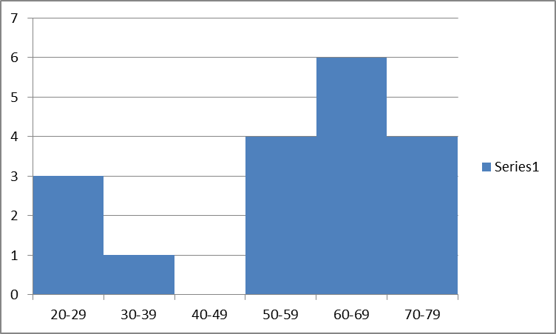
Excel Help
- To enter a formula in Excel, click on a cell, then type = followed by the formula. For example, to find the mean, type
=Average(
Highlight the cells you want to average, type ) and hit enter.

- When you start typing the name of the function, Excel will tell you what it expects next. For example, when you type =Quartile( Excel will display
QUARTILE(array,quart)
below the cell. That means it wants you to highlight the “array” (the data) you want to use, then type a comma, then tell it which quartile you want (either 1, 2, or 3).

- There are (as we will see later) two ways to compute the standard deviation depending on whether we have a sample or the whole population. The Excel functions are STDEV and STDEVP, respectively.

